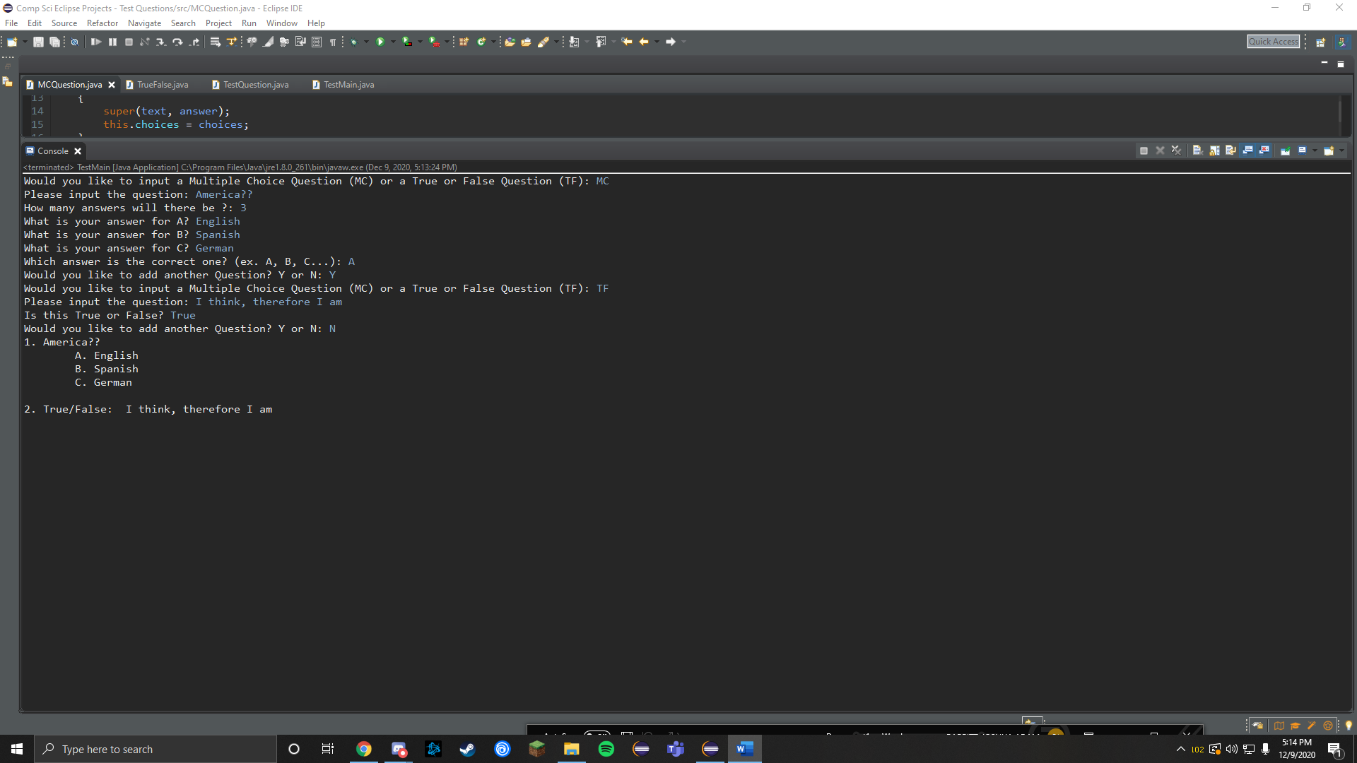

I created an array list of test questions, and added my MC Questions and True False Questions to the array list. Then I printed the questions in a proper format.